QAP 1 – Advanced Programming (Java)
Author: Laura Wiseman
Date: January 30th, 2025

- How many hours did it take you to complete this assessment?

A: I worked on this assignment for approximately 1 hour.

- What online resources you have used?

A: I used your lectures and PowerPoints! They were very helpful.

- Did you need to ask any of your friends in solving the problems?

A: I asked Noah Devine about some structures and wording!

- Did you need to ask questions to any of your instructors?

A: I did not ask an instructor any questions regarding this assignment.

- Rate this assignment.

A: I would rate this assignment a 9/10! It was interesting and I gained some confidence with my coding along with the concepts we’ve covered this week!

Problem #1: The Account Class
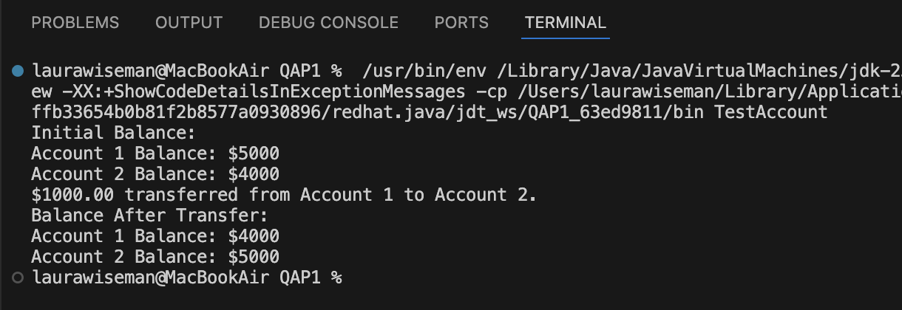
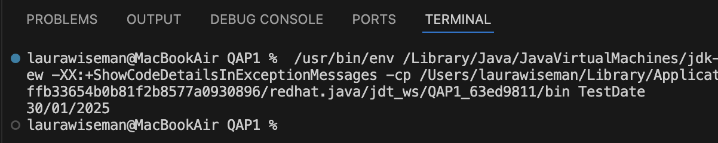
Problem #2: The Date Class

Problem #3: The Time Class
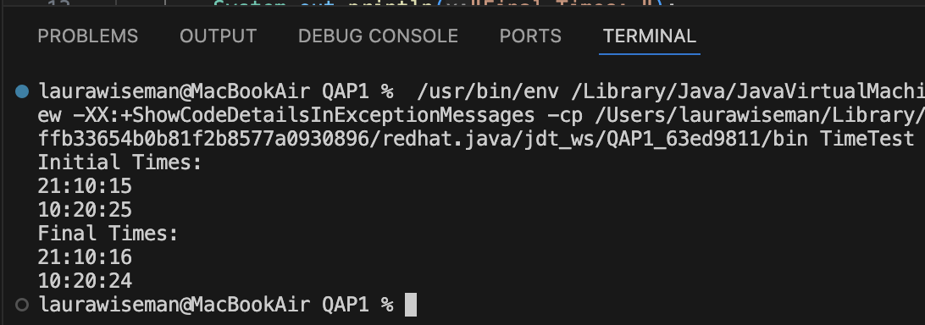

GitHub link:

https://github.com/lauraawiseman/QAP1-Java-S3

